ssOverlay

ssOverlay is screen masking program.

Who would benefit?
ssOverlay can help individuals who find it easier to read information on a computer with a colour overlay or screen masking. ssOverlay can also help to reduce screen glare on older monitors.

Main features:
- 8 screen colour masking options.
- Adjust transparency levels to suit individual preferences.

Get Started

- Click on the Reading icon on MyStudyBar and select ssOverlay.
- The ssOverlay icon will appear in the bottom task bar.

- Right click on the ssOverlay icon to view its settings menu.

- Click on the Settings options. A popup box will appear with the ssOverlay settings.
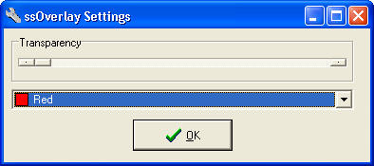

- To select a colour, click on the drop-down menu and choose a colour.

- Then change the transparency to suit your needs and click OK.
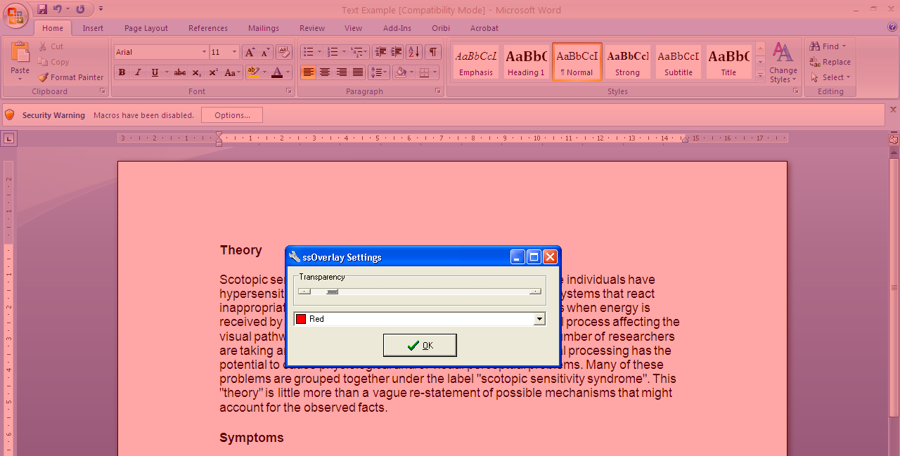

Exit ssOverlay
- Right click on the ssOverlay icon and select Exit.

